# **How to set JAVA_HOME in Windows 10**

In this tutorial I will show you how to **set JAVA_HOME** as environment variable in **Windows 10** operating system.

## **Why do I need to set JAVA_HOME?**

Many Java based programs like Tomcat require JAVA_HOME to be set as environment variable to work correctly. Please note JAVA_HOME should point to a JDK directory not a JRE one. The point of setting the environment variable is to let programs know in which directory executables like javac can be found.

## **1. Open Advanced System Settings**

In Windows 10 press Windows key + Pause Key, This will open the System Settings window. Go to Change settings and select the Advanced tab.

**Alternatively:**

Open “Windows search” – you will find it next to the Windows logo

[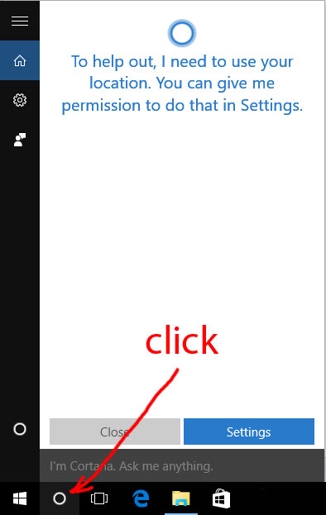](https://javatutorial.net/wp-content/uploads/2016/08/open-windows10-search.jpg)

open Windows 10 search

1. In the search field type in – advanced system settings

2. Click on the match on top of the list

[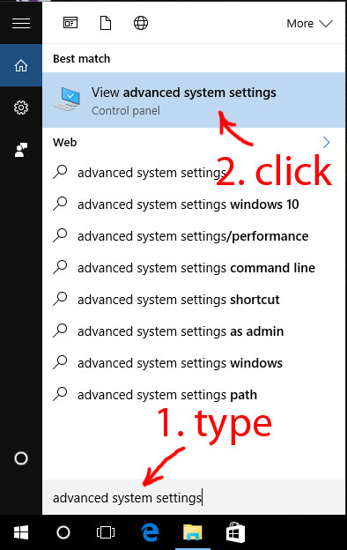](https://javatutorial.net/wp-content/uploads/2016/08/search-for-advanced-system-settings-in-windows-10.jpg)

Search for advanced system settings in Windows 10

## **2. Set JAVA_HOME Environment variable**

In “System Properties window” click “Environment Variables…”

[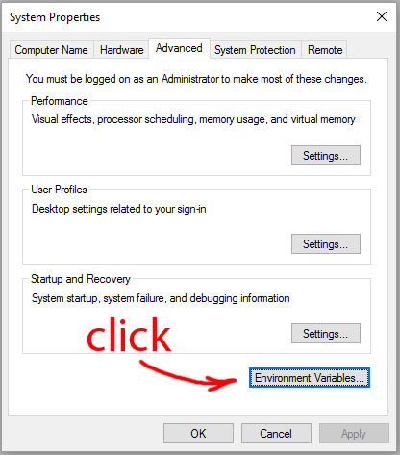](https://javatutorial.net/wp-content/uploads/2016/08/system-properties-window.jpg)

system properties window environment variables

Under “System variables” click the “New…” button and enter JAVA_HOME as “Variable name” and the path to your Java JDK directory under “Variable value”

[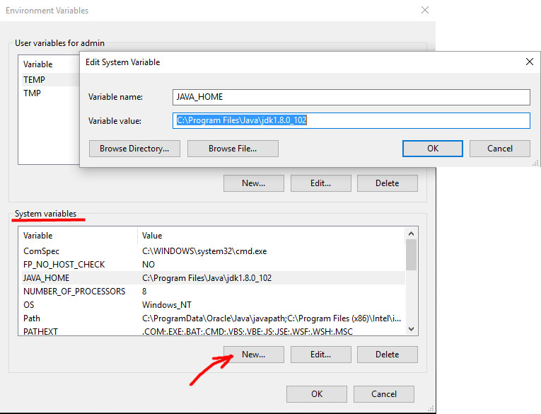](https://javatutorial.net/wp-content/uploads/2016/08/add-java_home-as-system-variable.jpg)

Add JAVA_HOME as system variable

## **3. Update System PATH**

1. In “Environment Variables” window under “System variables” select Path

2. Click on “Edit…”

3. In “Edit environment variable” window click “New”

4. Type in  %JAVA_HOME%\bin

[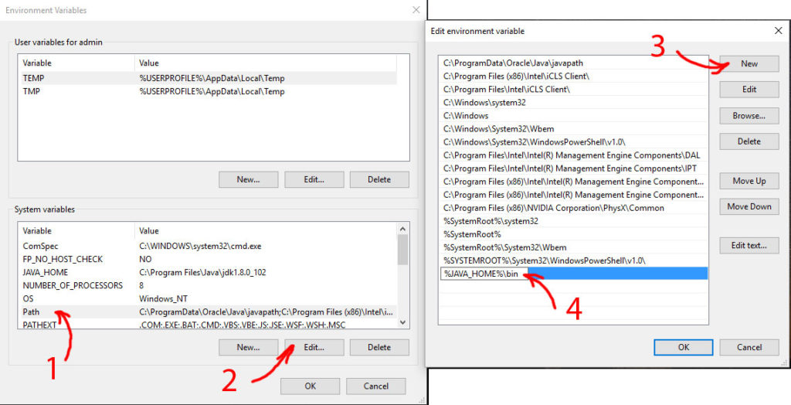](https://javatutorial.net/wp-content/uploads/2016/08/update-system-path.jpg)

Update system path

## **4. Test your configuration**

Open a new command prompt and type in:

1. **echo %JAVA_HOME%**

this will print out the directory JAVA_HOME points to or empty line if the environment variable is not set correctly

Now type in:

1. **javac -version**

this will print out the version of the java compiler if the Path variable is set correctly or “javac is not recognized as an internal or external command…” otherwise

[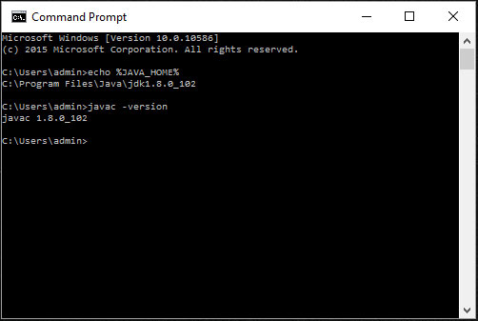](https://javatutorial.net/wp-content/uploads/2016/08/test-java_home-and-path.jpg)

Test JAVA_HOME and system path